How to use the Bridgemate terminal
The Bridgemate likes to sleep – press OK to wake it up

Press CANCEL to delete/correct an entry
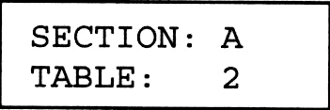
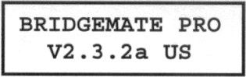
Initial Display: Press Next – If correct
OK. Section/Table Press OK
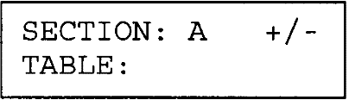
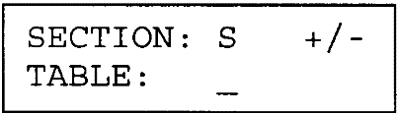
Alternatively If so, press + or –
you may see to change Section Press OK

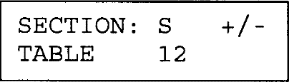
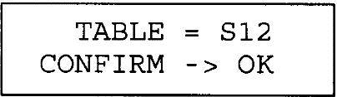
Key table Press The next If correct,
Number OK screen is Press OK

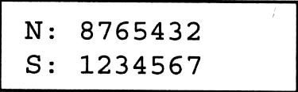
Enter member numbers of players initially sitting at this table:
Press OK after each number entered.

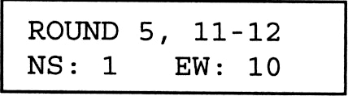
Round information is displayed: If Boards and opposing team
are correct – Press OK

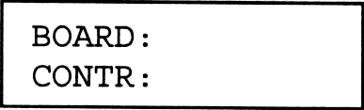
The following screen will appear: Enter Board number – press OK

After the bidding:
Enter: Contract (press “Pass” if passed out – press “0” if will be Late [or NO] Play)
X (if doubled) or XX (if redoubled) [omit if neither double or redouble]
N/S (once for N or twice for S) – or – E/W (once for E or twice for W)
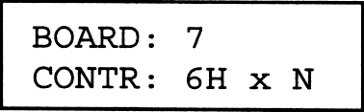
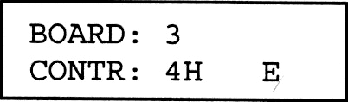
With correct BOARD and CONTRact :
Press OK

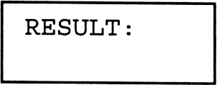
Press OK. The following
screen will appear: Play the hand.

After the board is played – press OK (to wake Bridgemate) and enter the result.
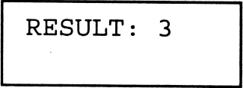
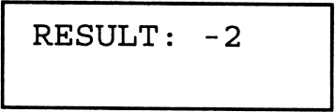
Key the number of tricks made or down: Press OK

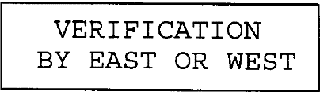
Note: CANCEL will return you to the Contract screen – if any questions.

Will appear for 1 to 2 seconds. Wait for the results to appear.

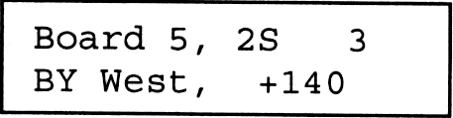
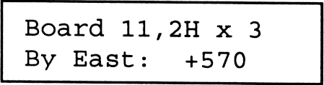
Pass the Bridgemate to East or West.
The score is from the Declarer’s viewpoint.
Note: CANCEL will return you to the Results screen – if results are not correct.

East (or West) checks the entry and, if correct, presses OK.
Please tell the person sitting East (or West) that they need to do this.

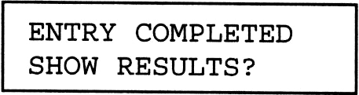
Do nothing and the Bridgemate will “go to sleep” in 20 seconds.
If you wish to see the comparative results of this board, and the
option is active for this game – press OK.

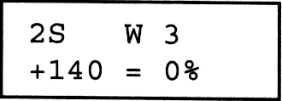
The score and percentage is from the Declarer’s point of view.
This is Bottom for E/W and TOP for N/S.

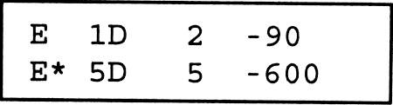
One last option (if active for this game) is a listing of results on
this board at other tables (N/S scores - highest to lowest).

090412D

How to use the Bridgemate terminal
The Bridgemate likes to sleep – press OK to wake it up

Press CANCEL to delete/correct an entry
Initial Display: Press Next – If correct
OK. Section/Table Press OK
Alternatively If so, press + or –
you may see to change Section Press OK

Key table Press The next If correct,
Number OK screen is Press OK

Enter member numbers of players initially sitting at this table:
Press OK after each number entered.

Round information is displayed: If Boards and opposing team
are correct – Press OK

The following screen will appear: Enter Board number – press OK

After the bidding:
Enter: Contract (press “Pass” if passed out – press “0” if will be Late [or NO] Play)
X (if doubled) or XX (if redoubled) [omit if neither double or redouble]
N/S (once for N or twice for S) – or – E/W (once for E or twice for W)
With correct BOARD and CONTRact :
Press OK

Press OK. The following
screen will appear: Play the hand.

After the board is played – press OK (to wake Bridgemate) and enter the result.
Key the number of tricks made or down: Press OK

Note: CANCEL will return you to the Contract screen – if any questions.

Will appear for 1 to 2 seconds. Wait for the results to appear.

Pass the Bridgemate to East or West.
The score is from the Declarer’s viewpoint.
Note: CANCEL will return you to the Results screen – if results are not correct.

East (or West) checks the entry and, if correct, presses OK.
Please tell the person sitting East (or West) that they need to do this.

Do nothing and the Bridgemate will “go to sleep” in 20 seconds.
If you wish to see the comparative results of this board, and the
option is active for this game – press OK.

The score and percentage is from the Declarer’s point of view.
This is Bottom for E/W and TOP for N/S.

One last option (if active for this game) is a listing of results on
this board at other tables (N/S scores - highest to lowest).

090412D

